1.

1.1. Creating DW.T_DAYS

create table t_days as

select time_id,day_name, day_number_in_week, day_number_in_month,

day_number_in_year

from u_dw_ext_references.ext_time_table

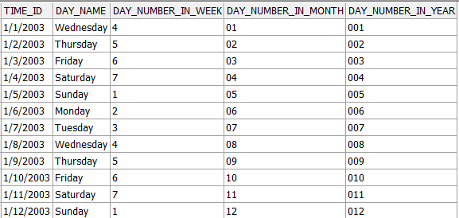

….

1.2. Creating DW.T_WEEKS

create table t_weeks as select time_id, calendar_week_number, week_ending_date

from u_dw_ext_references.ext_time_table;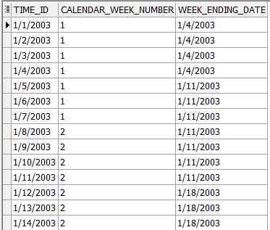

1.3. Creating DW.T_MONTHS

create table t_months as

select time_id, calendar_month_number, days_in_cal_month, calendar_month_name

from u_dw_ext_references.ext_time_table

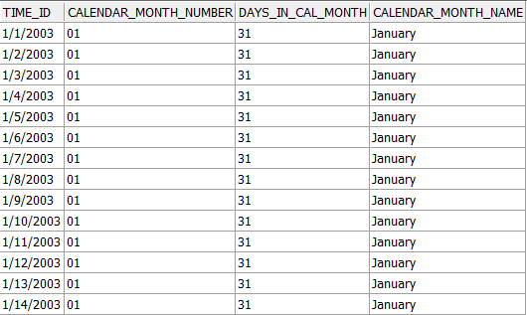

1.4. Creating DW.T_QUARTERS

create table t_quarters as

select time_id,days_in_cal_quarter, end_of_cal_quarter, calendar_quarter_number

from u_dw_ext_references.ext_time_table

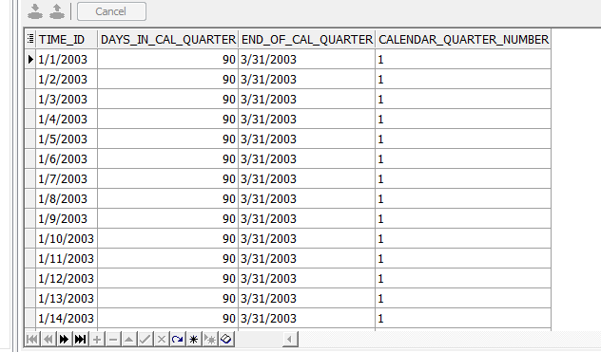

1.5. Creating DW.T_YEARS

create table t_years as

select time_id, days_in_cal_year, beg_of_cal_year, end_of_cal_year

from u_dw_ext_references.ext_time_table

